Lab 11 – Databases Part-II

Q1 - There are three tables in the database an author table has a first name, a last
name and an email address. A publisher table has a name, a street address, a city,
a state/ province, a country, and a Web site. A book table has a title and a
publication date. It also has one or more authors (a many-to-many relationship
with authors) and a single publisher (a one-to-many relationship - aka foreign
key - to publishers). Design a form which populates and retrieves the
information from the above database using Django.

Code -

#forms.py -
from django import forms
from .models import Book, Author, Publisher

class BookForm(forms.ModelForm):
class Meta:
model = Book
fields = ['title', 'publication_date', 'authors', 'publisher']

class AuthorForm(forms.ModelForm):
class Meta:
model = Author
fields = ['first_name', 'last_name', 'email']

class PublisherForm(forms.ModelForm):
class Meta:
model = Publisher
fields = ['name', 'street_address', 'city', 'state_province', 'country', 'website']

#views.py -
from django.shortcuts import render, redirect
from .models import Book, Author, Publisher
from .forms import BookForm, AuthorForm, PublisherForm

def book_create(request):
if request.method == 'POST':
form = BookForm(request.POST)
if form.is_valid():
form.save()
return redirect('book_list')
else:
form = BookForm()
return render(request, 'catalog/book_form.html', {'form': form})

def book_list(request):
books = Book.objects.all()
return render(request, 'catalog/book_list.html', {'books': books})

def author_create(request):
if request.method == 'POST':
form = AuthorForm(request.POST)
if form.is_valid():
form.save()
return redirect('book_list')
else:
form = AuthorForm()
return render(request, 'catalog/author_form.html', {'form': form})

def publisher_create(request):
if request.method == 'POST':
form = PublisherForm(request.POST)
if form.is_valid():
form.save()
return redirect('book_list')
else:
form = PublisherForm()
return render(request, 'catalog/publisher_form.html', {'form': form})

#models.py -
from django.db import models

class Author(models.Model):
first_name = models.CharField(max_length=100)
last_name = models.CharField(max_length=100)
email = models.EmailField()

def __str__(self):
return f"{self.first_name} {self.last_name}"

class Publisher(models.Model):
name = models.CharField(max_length=200)
street_address = models.CharField(max_length=200)
city = models.CharField(max_length=100)
state_province = models.CharField(max_length=100)
country = models.CharField(max_length=100)
website = models.URLField()

def __str__(self):
return self.name

class Book(models.Model):
title = models.CharField(max_length=200)
publication_date = models.DateField()
authors = models.ManyToManyField(Author)
publisher = models.ForeignKey(Publisher, on_delete=models.CASCADE)

def __str__(self):
return self.title

#admin.py -
from django.contrib import admin
from .models import Author, Publisher, Book

admin.site.register(Author)
admin.site.register(Publisher)
admin.site.register(Book)

#urls.py -
from django.urls import path
from . import views

urlpatterns = [
path('book/create/', views.book_create, name='book_create'),
path('book/list/', views.book_list, name='book_list'),
path('author/create/', views.author_create, name='author_create'),
path('publisher/create/', views.publisher_create, name='publisher_create'),
]

#book_list.html -
<!DOCTYPE html>
<html lang="en">
<head>
<meta charset="UTF-8">
<meta name="viewport" content="width=device-width, initial-scale=1.0">
<title>Books List</title>
<style>
body {
font-family: 'Arial', sans-serif;
margin: 0;
padding: 0;
background-color: #f4f7f6;
}
header {
background-color: #007BFF;
color: white;
padding: 1rem;
text-align: center;
}
header h1 {
margin: 0;
}
footer {
background-color: #333;
color: white;
text-align: center;
padding: 1rem;
position: fixed;
width: 100%;
bottom: 0;
}
.container {
max-width: 1200px;
margin: 0 auto;
padding: 20px;
}
.btn {
background-color: #007BFF;
color: white;
border: none;
padding: 10px 20px;
border-radius: 5px;
cursor: pointer;
text-decoration: none;
}
.btn:hover {
background-color: #0056b3;
}
table {
width: 100%;
margin-top: 20px;
border-collapse: collapse;
}
table th, table td {
padding: 12px;
text-align: left;
border: 1px solid #ddd;
}
table th {
background-color: #007BFF;
color: white;
}
</style>
</head>
<body>
<header>
<h1>Book Catalog</h1>
</header>

<div class="container">
<h2>Books in the Catalog</h2>

<table>
<thead>
<tr>
<th>Title</th>
<th>Authors</th>
<th>Publisher</th>
<th>Publication Date</th>
</tr>
</thead>
<tbody>
{% for book in books %}
<tr>
<td>{{ book.title }}</td>
<td>
{% for author in book.authors.all %}
{{ author.first_name }} {{ author.last_name }}<br>
{% endfor %}
</td>
<td>{{ book.publisher.name }}</td>
<td>{{ book.publication_date }}</td>
</tr>
{% endfor %}
</tbody>
</table>

<div style="margin-top: 20px;">
<a href="{% url 'book_create' %}" class="btn">Add New Book</a>
</div>
</div>

<footer>
<p>&copy; 2025 Book Catalog</p>
</footer>
</body>
</html>

#book_form.html -
<!DOCTYPE html>
<html lang="en">
<head>
<meta charset="UTF-8">
<meta name="viewport" content="width=device-width, initial-scale=1.0">
<title>Create a New Book</title>
<style>
body {
font-family: 'Arial', sans-serif;
margin: 0;
padding: 0;
background-color: #f4f7f6;
}
header {
background-color: #007BFF;
color: white;
padding: 1rem;
text-align: center;
}
header h1 {
margin: 0;
}
footer {
background-color: #333;
color: white;
text-align: center;
padding: 1rem;
position: fixed;
width: 100%;
bottom: 0;
}
.container {
max-width: 800px;
margin: 0 auto;
padding: 20px;
}
.btn {
background-color: #007BFF;
color: white;
border: none;
padding: 10px 20px;
border-radius: 5px;
cursor: pointer;
text-decoration: none;
}
.btn:hover {
background-color: #0056b3;
}
.form-group {
margin-bottom: 1rem;
}
.form-group label {
font-weight: bold;
}
.form-group input,
.form-group select {
width: 100%;
padding: 10px;
margin-top: 5px;
border: 1px solid #ccc;
border-radius: 5px;
background-color: #fff;
}
</style>
</head>
<body>
<header>
<h1>Book Catalog</h1>
</header>

<div class="container">
<h2>Create a New Book</h2>

<form method="post">
{% csrf_token %}
<div class="form-group">
<label for="id_title">Book Title:</label>
{{ form.title }}
</div>
<div class="form-group">
<label for="id_publication_date">Publication Date:</label>
{{ form.publication_date }}
</div>
<div class="form-group">
<label for="id_authors">Authors:</label>
{{ form.authors }}
</div>
<div class="form-group">
<label for="id_publisher">Publisher:</label>
{{ form.publisher }}
</div>

<button type="submit" class="btn">Save Book</button>
</form>

<div style="margin-top: 20px;">
<a href="{% url 'book_list' %}" class="btn">Back to Books List</a>
</div>
</div>

<footer>
<p>&copy; 2025 Book Catalog</p>
</footer>
</body>
</html>

#author_form.html
<!DOCTYPE html>
<html lang="en">
<head>
<meta charset="UTF-8">
<meta name="viewport" content="width=device-width, initial-scale=1.0">
<title>Create a New Author</title>
<style>
body {
font-family: 'Arial', sans-serif;
margin: 0;
padding: 0;
background-color: #f4f7f6;
}
header {
background-color: #007BFF;
color: white;
padding: 1rem;
text-align: center;
}
header h1 {
margin: 0;
}
footer {
background-color: #333;
color: white;
text-align: center;
padding: 1rem;
position: fixed;
width: 100%;
bottom: 0;
}
.container {
max-width: 800px;
margin: 0 auto;
padding: 20px;
}
.btn {
background-color: #007BFF;
color: white;
border: none;
padding: 10px 20px;
border-radius: 5px;
cursor: pointer;
text-decoration: none;
}
.btn:hover {
background-color: #0056b3;
}
.form-group {
margin-bottom: 1rem;
}
.form-group label {
font-weight: bold;
}
.form-group input {
width: 100%;
padding: 10px;
margin-top: 5px;
border: 1px solid #ccc;
border-radius: 5px;
background-color: #fff;
}
</style>
</head>
<body>
<header>
<h1>Book Catalog</h1>
</header>

<div class="container">
<h2>Create a New Author</h2>

<form method="post">
{% csrf_token %}
<div class="form-group">
<label for="id_first_name">First Name:</label>
{{ form.first_name }}
</div>
<div class="form-group">
<label for="id_last_name">Last Name:</label>
{{ form.last_name }}
</div>
<div class="form-group">
<label for="id_email">Email:</label>
{{ form.email }}
</div>

<button type="submit" class="btn">Save Author</button>
</form>

<div style="margin-top: 20px;">
<a href="{% url 'book_list' %}" class="btn">Back to Books List</a>
</div>
</div>

<footer>
<p>&copy; 2025 Book Catalog</p>
</footer>
</body>
</html>

#publisher_form.html
<!DOCTYPE html>
<html lang="en">
<head>
<meta charset="UTF-8">
<meta name="viewport" content="width=device-width, initial-scale=1.0">
<title>Create a New Author</title>
<style>
body {
font-family: 'Arial', sans-serif;
margin: 0;
padding: 0;
background-color: #f4f7f6;
}
header {
background-color: #007BFF;
color: white;
padding: 1rem;
text-align: center;
}
header h1 {
margin: 0;
}
footer {
background-color: #333;
color: white;
text-align: center;
padding: 1rem;
position: fixed;
width: 100%;
bottom: 0;
}
.container {
max-width: 800px;
margin: 0 auto;
padding: 20px;
}
.btn {
background-color: #007BFF;
color: white;
border: none;
padding: 10px 20px;
border-radius: 5px;
cursor: pointer;
text-decoration: none;
}
.btn:hover {
background-color: #0056b3;
}
.form-group {
margin-bottom: 1rem;
}
.form-group label {
font-weight: bold;
}
.form-group input {
width: 100%;
padding: 10px;
margin-top: 5px;
border: 1px solid #ccc;
border-radius: 5px;
background-color: #fff;
}
</style>
</head>
<body>
<header>
<h1>Book Catalog</h1>
</header>

<div class="container">
<h2>Create a New Author</h2>

<form method="post">
{% csrf_token %}
<div class="form-group">
<label for="id_first_name">First Name:</label>
{{ form.first_name }}
</div>
<div class="form-group">
<label for="id_last_name">Last Name:</label>
{{ form.last_name }}
</div>
<div class="form-group">
<label for="id_email">Email:</label>
{{ form.email }}
</div>

<button type="submit" class="btn">Save Author</button>
</form>

<div style="margin-top: 20px;">
<a href="{% url 'book_list' %}" class="btn">Back to Books List</a>
</div>
</div>

<footer>
<p>&copy; 2025 Book Catalog</p>
</footer>
</body>
</html>

Output -
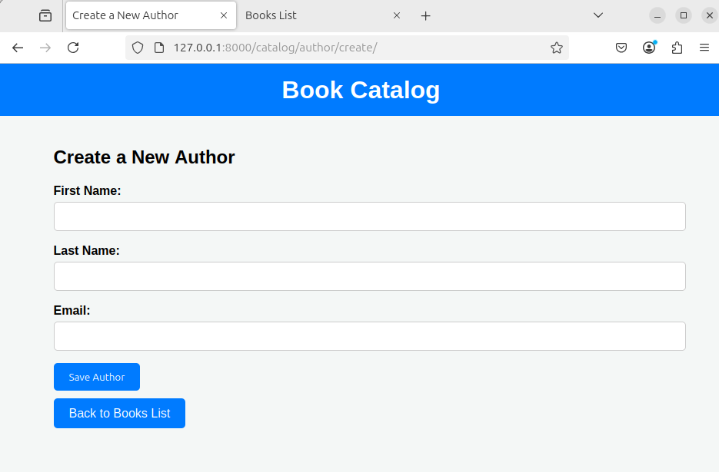
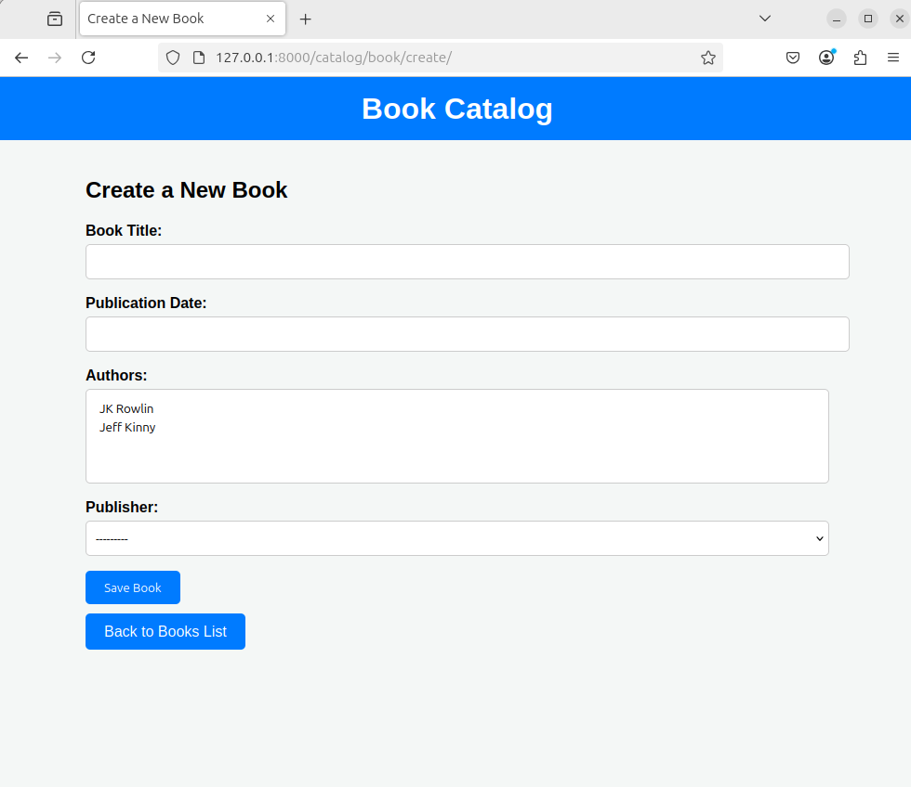

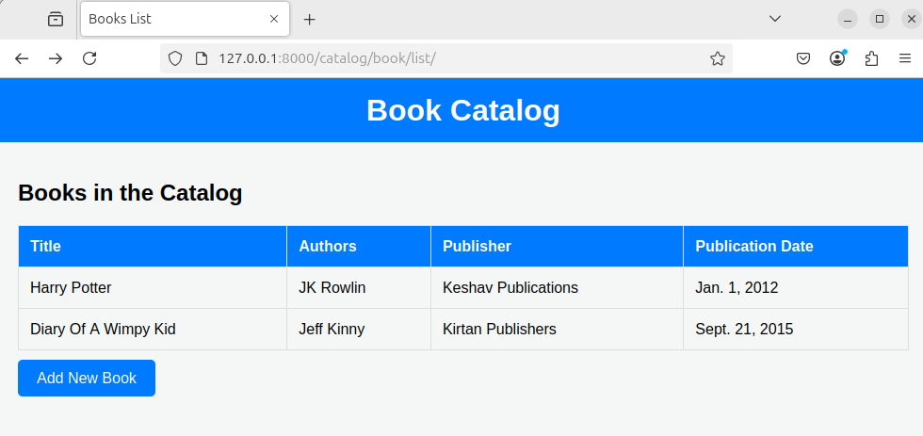
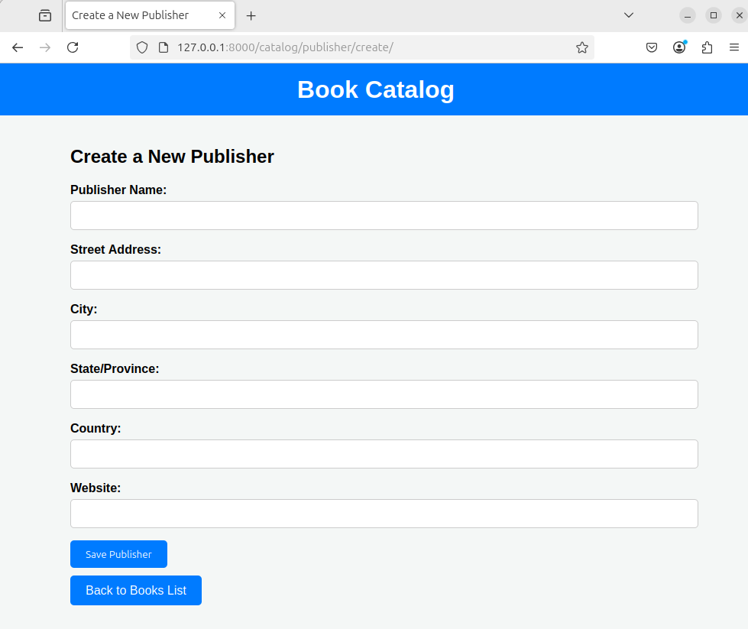
Q2 - Create a Django Page for entry of a Product information (title, price and
description) and save it into the db. Create the index page where you would view
the product entries in an unordered list.

Code -

#forms.py -
from django import forms
from .models import Product

class ProductForm(forms.ModelForm):
class Meta:
model = Product
fields = ['title', 'price', 'description']

#models.py -
from django.db import models

class Product(models.Model):
title = models.CharField(max_length=100)
price = models.DecimalField(max_digits=10, decimal_places=2)
description = models.TextField()

def __str__(self):
return self.title

#views.py -
from django.shortcuts import render, redirect
from .forms import ProductForm
from .models import Product

def index(request):
products = Product.objects.all()
return render(request, 'products/index.html', {'products': products})

def product_entry(request):
if request.method == 'POST':
form = ProductForm(request.POST)
if form.is_valid():
form.save()
return redirect('index')
else:
form = ProductForm()
return render(request, 'products/product_entry.html', {'form': form})

#urls.py -
from django.urls import path
from . import views

urlpatterns = [
path('', views.index, name='index'),
path('product/entry/', views.product_entry, name='product_entry'),
]

#product_entry.html -
<!DOCTYPE html>
<html lang="en">
<head>
<meta charset="UTF-8">
<meta name="viewport" content="width=device-width, initial-scale=1.0">
<title>Product Entry</title>
<style>
body {
font-family: Arial, sans-serif;
margin: 0;
padding: 0;
background-color: #f8f8f8;
}
header {
background-color: #333;
color: white;
padding: 10px 0;
text-align: center;
}
.container {
width: 50%;
margin: 0 auto;
padding: 20px;
background-color: white;
box-shadow: 0 0 10px rgba(0, 0, 0, 0.1);
}
.btn {
background-color: #007BFF;
color: white;
padding: 10px 20px;
border: none;
border-radius: 5px;
cursor: pointer;
text-decoration: none;
}
.btn:hover {
background-color: #0056b3;
}
.form-group {
margin-bottom: 1rem;
}
.form-group label {
font-weight: bold;
}
.form-group input,
.form-group textarea {
width: 100%;
padding: 10px;
margin-top: 5px;
border: 1px solid #ccc;
border-radius: 5px;
background-color: #fff;
}
</style>
</head>
<body>
<header>
<h1>Product Catalog</h1>
</header>

<div class="container">
<h2>Add New Product</h2>

<form method="post">
{% csrf_token %}
<div class="form-group">
<label for="id_title">Product Title:</label>
{{ form.title }}
</div>
<div class="form-group">
<label for="id_price">Price:</label>
{{ form.price }}
</div>
<div class="form-group">
<label for="id_description">Description:</label>
{{ form.description }}
</div>
<button type="submit" class="btn">Save Product</button>
</form>

<br>
<a href="{% url 'index' %}" class="btn">Back to Product List</a>
</div>
</body>
</html>

#index.html -
<!DOCTYPE html>
<html lang="en">
<head>
<meta charset="UTF-8">
<meta name="viewport" content="width=device-width, initial-scale=1.0">
<title>Product Catalog</title>
<style>
body {
font-family: Arial, sans-serif;
margin: 0;
padding: 0;
background-color: #f8f8f8;
}
header {
background-color: #333;
color: white;
padding: 10px 0;
text-align: center;
}
.container {
width: 70%;
margin: 0 auto;
padding: 20px;
background-color: white;
box-shadow: 0 0 10px rgba(0, 0, 0, 0.1);
}
.btn {
background-color: #007BFF;
color: white;
padding: 10px 20px;
border: none;
border-radius: 5px;
cursor: pointer;
text-decoration: none;
}
.btn:hover {
background-color: #0056b3;
}
ul {
list-style-type: none;
padding: 0;
}
li {
margin-bottom: 20px;
padding: 10px;
background-color: #f1f1f1;
border-radius: 5px;
}
</style>
</head>
<body>
<header>
<h1>Product Catalog</h1>
</header>

<div class="container">
<h2>Product List</h2>
<ul>
{% for product in products %}
<li>
<strong>{{ product.title }}</strong><br>
<em>Price: ${{ product.price }}</em><br>
<p>{{ product.description }}</p>
</li>
{% endfor %}
</ul>

<br>
<a href="{% url 'product_entry' %}" class="btn">Add New Product</a>
</div>
</body>
</html>

Output -

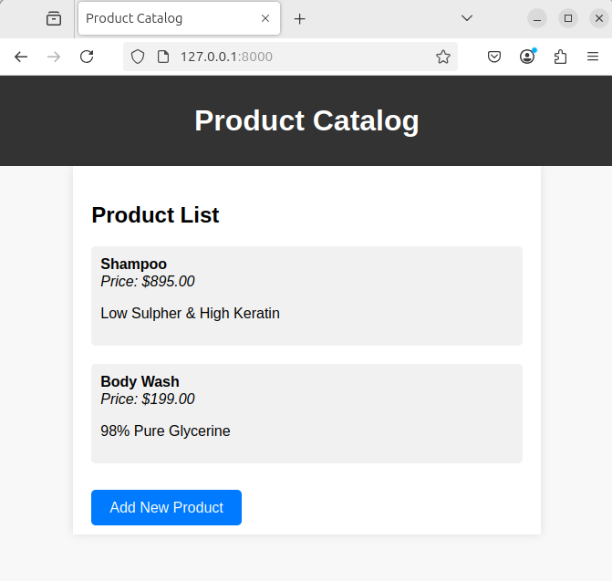
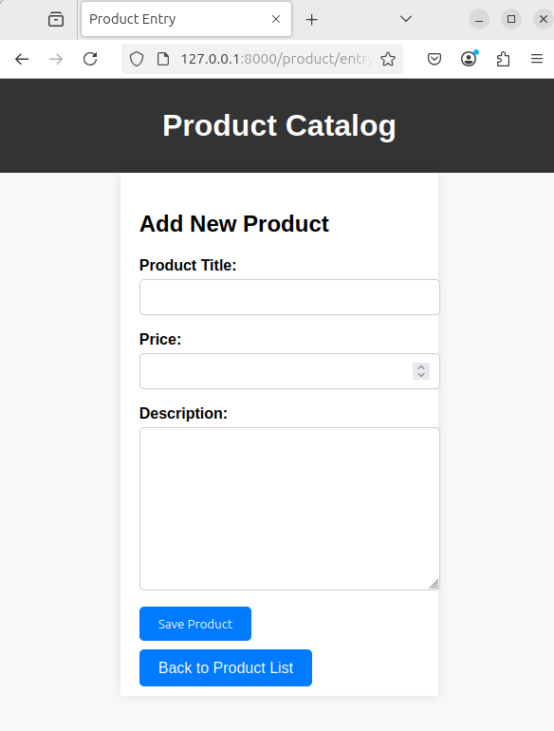

Q3 - Create a web page with DropDownList, Textboxes and Buttons. Assume the
table ‘Human’ with First name, Last name, Phone, Address and City as fields.
When the page is loaded, only first names will be displayed in the drop-down
list. On selecting the name, other details will be displayed in the respective
TextBoxes. On clicking the update button, the table will be updated with new
entries made in the text box. On clicking the delete button, the selected record
will be deleted from the table, and the DropDownList is refreshed.

Code -

#forms.py -
from django import forms
from .models import Human

class HumanForm(forms.ModelForm):
class Meta:
model = Human
fields = ['first_name', 'last_name', 'phone', 'address', 'city']

#views.py -
from django.shortcuts import render, redirect
from .models import Human
from .forms import HumanForm

def human_details(request):
humans = Human.objects.all()
human = None
form = None

if request.method == 'POST':
human_id = request.POST.get('human_id')
action = request.POST.get('action')

if action == 'Update':
human = Human.objects.get(id=human_id)
form = HumanForm(request.POST, instance=human)
if form.is_valid():
form.save()
elif action == 'Delete':
human = Human.objects.get(id=human_id)
human.delete()

return redirect('human_details')

if 'human_id' in request.GET:
human_id = request.GET['human_id']
human = Human.objects.get(id=human_id)
form = HumanForm(instance=human)

return render(request, 'humans/human_details.html', {
'humans': humans,
'form': form,
'human': human,
})

#models.py -
from django.db import models

class Human(models.Model):
first_name = models.CharField(max_length=100)
last_name = models.CharField(max_length=100)
phone = models.CharField(max_length=15)
address = models.CharField(max_length=255)
city = models.CharField(max_length=100)

def __str__(self):
return self.first_name

#urls.py -
from django.urls import path
from . import views

urlpatterns = [
path('human/details/', views.human_details, name='human_details'),
]

#human_details.html -
<!DOCTYPE html>
<html lang="en">
<head>
<meta charset="UTF-8">
<meta name="viewport" content="width=device-width, initial-scale=1.0">
<title>Human Details</title>
<style>
body {
font-family: Arial, sans-serif;
margin: 0;
padding: 0;
background-color: #f4f7f6;
}
header {
background-color: #333;
color: white;
padding: 10px 0;
text-align: center;
}
.container {
width: 50%;
margin: 20px auto;
padding: 20px;
background-color: white;
box-shadow: 0 0 10px rgba(0, 0, 0, 0.1);
}
.btn {
background-color: #007BFF;
color: white;
padding: 10px 20px;
border: none;
border-radius: 5px;
cursor: pointer;
}
.btn:hover {
background-color: #0056b3;
}
select, input {
width: 100%;
padding: 10px;
margin-bottom: 10px;
border: 1px solid #ccc;
border-radius: 5px;
background-color: #fff;
}
</style>
</head>
<body>

<header>
<h1>Human Details</h1>
</header>

<div class="container">
<form method="GET" action="">
<label for="human_id">Select First Name:</label>
<select name="human_id" id="human_id" onchange="this.form.submit()">
<option value="">--Select--</option>
{% for human in humans %}
<option value="{{ human.id }}" {% if human.id == human.id %} selected {% endif %}>{{ human.first_name }}</option>
{% endfor %}
</select>
</form>

{% if human %}
<form method="POST">
{% csrf_token %}
<input type="hidden" name="human_id" value="{{ human.id }}">

<label for="id_first_name">First Name:</label>
{{ form.first_name }}

<label for="id_last_name">Last Name:</label>
{{ form.last_name }}

<label for="id_phone">Phone:</label>
{{ form.phone }}

<label for="id_address">Address:</label>
{{ form.address }}

<label for="id_city">City:</label>
{{ form.city }}

<button type="submit" name="action" value="Update" class="btn">Update</button>
<button type="submit" name="action" value="Delete" class="btn">Delete</button>
</form>
{% endif %}
</div>

</body>
</html>

Output -

